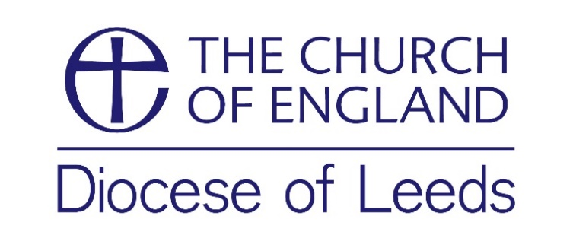

Consent form concerning the use of photographs/videos

Name of subject: _________________________________________________________________

Email (or contact address): ____________________________________________

_________________________________________________________________

Location of photograph: _______________________________________________

The Diocese of Leeds would like to take your photograph or a video of you for promotional purposes. These images may appear in our printed publications, on our website, or social media accounts. Please answer questions one, two and three below, then sign and date the form where shown. Any image taken or information you provide will not be used for any other purposes.
Please circle your answer

- May we use your/your child’s image in printed, web and social
media produced by the Diocese of Leeds? Yes/No

2. May we use your/your child’s image on our website? Yes/No

3. May we use your/your child’s image for general publicity ie Yes/No
newspapers etc.

Please note that websites can be seen throughout the world and not just in the United Kingdom, where UK law applies. Conditions for use of any image taken are printed below.

I have read and understood the conditions of use.
Signed by subject (plus parent/guardian if under 16; just parent/guardian if under 12)

Signature(s): _______________________________________

Date: __________________

Conditions for use:
We will not include personal contact details of any persons in an image on our website
or in printed publications.

